MCQ

1.Full Form of KVM. Single choice.

Kernal

Virtual correct

machine

Karnal Virtual machine

2.How many layers are there in Iot architecture. Multiple choice.

4

5

2 correct

1

Short Answer

3.What is a fuzzy set ?. Multi Line Text.



 In classical **set** theory, the membership of elements in a **set** is assessed in binary terms according to a bivalent condition

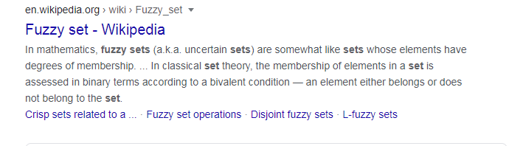

4.What is genetic algorithm?. Multi Line Text.



Long Answer

Write your Name, Roll No. and Page no. on the top of each page. Use a separate sheet for each question. Upload a single file for all questions ordered sequentially.

5.Q.1 What is a neural network?

Q.2 What is backpropagation?

Q.3 What is Soft Computing?

(Non-anonymous question

)

. .

Upload file

File number limit: 1Single file size limit: 100MBAllowed file types: PDF